Converting CSV to JSON using Python (for Windows)

1. Download Python: <https://www.python.org/downloads/>
2. Install the downloaded .exe file:
   1. Select ‘Add Python to PATH’
   2. Click ‘Install Now’

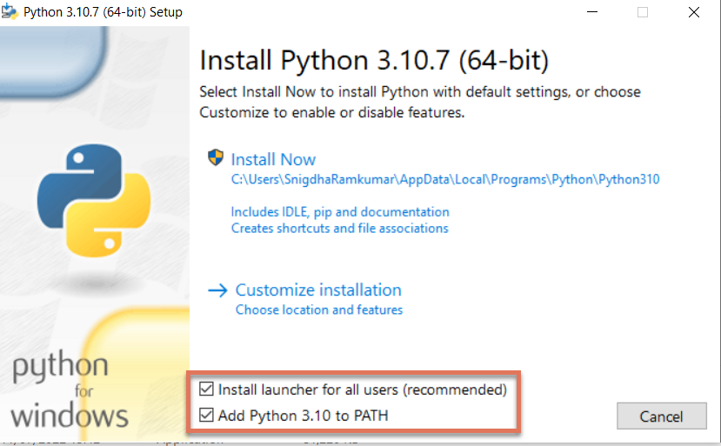

1. Open Windows Command Prompt
2. Type: python -m pip install pandas
3. Download the *JSONExport.py* file to Desktop (or download the file and move it to the Desktop within File Explorer)
4. Within this file:
   1. Edit the PATH to read the CSV file
   2. Edit the DESTINATION
5. In the terminal (in either VSCode or Windows cmd), type cd Desktop
6. To run the code, type python JSONExport.py
7. If the code executes successfully, a success message will be displayed on screen, and the converted JSON file will be downloaded to the given destination